DISTRICT OF COLUMBIA
Office of Administrative Hearings

____________________________________________
:
GABRIEL FINEMAN, :
:
Tenant/Petitioner, :
: Case No.: 2016 DHCD TP 30,842
V. : 3003 Van Ness Street, N.W., : Apt. W-1131
:
SMITH PROPERTY HOLDINGS VAN NESS L.P., :
:
Housing Provider/Respondent :
___________________________________________ :

Tenant’s Motion for Summary Judgment
Tenant/Petitioner Gabriel Fineman ("Tenant"), moves for summary judgment. In support hereof, the Tenant submits the attached Memorandum of Points and Authorities.
Respectfully submitted,
Tenant/Petitioner

_______________________________
Dated: June 28, 2016 Gabriel Fineman
3003 Van Ness St, NW
Apartment W-1131
Washington, DC 20008
Telephone (202) 290-7460
Certificate of Service
I hereby certify that a copy of the foregoing Motion and Memorandum of Points and Authorities in Support thereof was served on this the August 22, 2016, by first class mail, postage pre-paid and by personal delivery upon:
Smith Property Holdings Van Ness L.P.
3003 Van Ness Street, N.W.
Rental Office
Washington, D.C. 20008

____________________________
Gabriel Fineman
Memorandum of Points and Authorities in Support of
Tenant’s Motion for Summary Judgment
Gabriel Fineman
Tenant/Petitioner
V.
SMITH PROPERTY HOLDINGS VAN NESS L.P. :
Housing Provider/Respondent
Case No.: 2016 DHCD TP 30,842 3003 Van Ness Street, N.W., Apt. W-1131

DISTRICT OF COLUMBIA
Office of Administrative Hearings
DISTRICT OF COLUMBIA
Office of Administrative Hearings

____________________________________________
:
GABRIEL FINEMAN, :
:
Tenant/Petitioner, :
: Case No.: 2016 DHCD TP 30,842
V. : 3003 Van Ness Street, N.W., : Apt. W-1131
:
SMITH PROPERTY HOLDINGS VAN NESS L.P., :
:
Housing Provider/Respondent :
___________________________________________ :

Tenant/Petitioner Gabriel Fineman ("Tenant") submits its memorandum of points and authorities in support of its Motion for Summary Judgment. In support thereof, Tenant states as follows:
- The Claims
In the Tenant Petition filed on July 12, 2016, Tenant/Petitioner Gabriel Fineman (“Petitioner”) alleged that (i) the Housing Provider did neither provided the correct notices of rent increase to the Tenant nor filed the correct rent increase forms with the RAD; and (ii) this was done as a willful act that calls for a penalty to be assessed by the adjudicator.
In the Complaint Details, Petitioner states that:
The Housing Provider provided the Tenant with an incorrect RAD form 8 and filed an incorrect RAD form 9 with the RAD and has failed to correct the filing despite notice. The Housing Provider incorrectly stated the rent charged by almost $1,000.
This petition is only to correct the line entitled "Your current rent charged" on the RAD form 8 and the associated filed RAD form 9. It does not deal with the lease, how the rent is calculated, flex-leases, concession leases, rent ceilings or other items normally decided in a civil court.
II. Factual Background
A. The Housing Accommodation.
Smith Property Holdings Van Ness L.P is the owner of the residential rental accommodation located at 3003 Van Ness Street, N.W. in Washington, D.C. (the "Housing Accommodation"). Equity Residential Management, L.L.C. manages the Housing Accommodation. Petitioner has resided at the Housing Accommodation since December 2013. Petitioner rented Unit W-1131 (the “Unit”). [Exhibit A, Affidavit of Gabriel Fineman.]
B. The RAD Form 8 and RAD form 9.
The Housing Provider is required to provide each tenant with a Notice to Tenants of Adjustment in Rent Charged before it increases rents [42 DCMR 4205.4 (a)] and file that same information with the RAD. [42 DCMR 4205.4 (d)].
On September 18, 2015 Housing Provider sent a RAD form 8 notice to Tenant that the rent for the unit would be increasing from $3,114 to $3,161 effective December 22, 2015. A copy of the Rad form 8 is attached as Exhibit B. Thereafter, on or about September 22, 2015, Housing Provider filed a Certificate of Notice of Rent Increase (RAD form 9) with the District of Columbia’s Rental Accommodations Division. A copy of the Certificate of Notice of Rent Increase is attached as Exhibit C.
On or about October 7, 2015 the Tenant sent notice to the Housing Provider that the RAD form 8 was incorrect and that it should be corrected. That notice is attached as Exhibit D. No reply was ever received. [Affidavit, Exhibit A.]

II. Standard for Granting Summary Judgment
The District of Columbia Office of Administrative Hearings (“OAH”) Rule 2828.1 provides, “Motions for summary adjudication or comparable relief may be filed in accordance with Rule 2812.” OAH Rule 2812 provides instructions for the filing of motions, generally, but it does not specifically address the standard to determine whether summary judgment is appropriate. Where a procedural rule is not specifically addressed by the OAH Rules, the Office of Administrative Hearings may rely upon the District of Columbia Superior Court Rules of Civil Procedure as persuasive authority. See OAH Rule 2801.2.
District of Columbia Superior Court Rule of Civil Procedure 56 provides that summary judgment is appropriate if there is "no genuine issue as to any material fact and the moving party is entitled to a judgment as a matter of law." See also Musa v. Continental Ins. Co., 644 A.2d 999, 100102 (D.C. 1994). Only disputes over facts, viewed in the light most favorable to the non-moving party, which might legitimately affect the outcome of a trial are
"material" under Rule 56. See Anderson v. Liberty Lobby, Inc., 477 U.S. 242, 250 (1986) (There is no issue to be decided at trial unless there is sufficient evidence favoring the non-moving party for the finder of fact to return a verdict for that party.); see also Barnstead Broadcasting Corp. v. Offshore Broadcasting Corp., 886 F.Supp. 874, 878 (D.C. Cir. 1995) (Disputed material facts are those that might affect outcome of the suit under governing law.); Clayton v. Owens-Coming Fiberglass Corp., 662 A.2d 1374, 1381 (D.C. 1995).
III. Analysis
- There are no material issues of fact.
  - Because this petition deals with a single issue, there are no material facts in dispute. The RAD form 8 is attached as Exhibit B and the RAD form 9 as Exhibit C. The only issue is if they were properly filled out with the correct current rent charged and that depends only on how the statutory definition of "rent" is interpreted by the Hearing Examiner. These are very simple forms that should be easy to fill out. Form 9 is a summary of form 8 notices to tenants that is a simple form containing only two numbers that are not computed: 'Your current rent charged' and 'the dollar adjustment to your rent charged'. The Housing Provider incorrectly stated the rent charged to the Tenant by almost $1,000.
- There is no material issue at law that are not defined in the Statute
  - There is only one section of the law involved and that is the definition of the term "rent" as used in various phrases.
As stated below, the definition of rent is both clear from its definition in the statute and by its general and common meaning.
b. The term "Your current rent charged" is what the Housing Provider tries to collect.
The term "Your current rent charged" is four words. The word 'your' clearly refers to the Tenant who received the notice. 'Current' mean now, or in this case, October 2015. Rent is a term defined as follows in DC Code section §42-3501.03 (28) that applies to all of chapter 35, including the filing of RAD forms 8 and 9. ‘Rent’ means
the entire amount of money, money's worth, benefit, bonus, or gratuity demanded, received, or charged by a housing provider as a condition of occupancy or use of a rental unit, its related services, and its related facilities. [DC Code section §42-3501.03 (28)]
Note that this definition does not depend on how the rent is computed or what rent might have been demanded, but on the actual amount demanded, received or charged by the Housing Provider. It is likewise not dependent on any contract between the Housing Provider and any Tenant or upon any contractual definition of terms. It is an independent definition of how the term "rent" should be construed throughout chapter 35 of Title 42 of the DC Code, including the requirements to issue RAD form 8 and to file RAD form 9.
c. What "Charged" means.
Finally the word "charged" seems redundant since it presumed in the definition of "rent". However, since the amount demanded or received might differ from what is charged, that definition is important. The dictionary definitions are rather clear. It means 'the price demanded for something' (Webster) or 'an amount of money that you have to pay' (McMillan) or 'demand (an amount) as a price from someone for a service rendered or goods supplied' (Oxford). Thus it is the amount that the Housing Provider hoped or expected to receive each month from the Tenant.
d. The amount of rent charged can also be derived from the actions of the Housing Provider.
In the case of the Tenant, Gabriel Fineman allowed the housing provider to debit his bank account each month and thus the three possible amounts in the definition of rent were always the same. The amount that the Housing Provider demand from the Tenant's bank, receive by ACH transfer and charged to the Tenant's account each month was $2,329. A copy of a bank statement showing the drafting on the Tenant's account by the Housing Provider is attached as Exhibit E. That is clearly the then current rent for the unit plus related garage space (that had a separate charge of $160 per month). This means that the actual rent charged, demanded and received for unit W-1131 was $2,169. However, the amount of current rent charged shown on RAD form 8 was falsely stated as $3,114.
e. Another way to look at the amount of rent charged.
Another way to look at rent charged is the consider under what conditions the Housing Provider could go into Landlord Tenant Court and request eviction for non-payment of rent. Could it claim that the Tenant was in default because he failed to pay some maximum legal rent, or some ceiling rent or some rent that was not what was asked for or expected each month? Of course not. Could the Housing Provider claim that the amount of money it was owed under the lease was some higher amount not demanded or even required by a lease? It would be laughed out of court.
IV. Relief
Accordingly, the Tenant petition should be granted and the Housing Provider should be ordered to: (i) to correct the existing filings; (ii) notify the tenants of such corrections, and (iii) make future notices and filings correctly.
Furthermore, the actions of the Housing Provider in filing these false RAD 8 and RAD 9 forms was unlawful. The Rad 9 form states:
I declare, affirm and ratify under penalty of perjury that the foregoing information is complete and accurate to the best of my knowledge. I fully understand and acknowledge that my signature below shall be deemed as the taking of an oath or affirmation regarding all of the information provided herein, to which the sanctions for perjury, false swearing or false statements under D.C. OFFICIAL CODE §§ 22-2402, 2404 & 2405 (Supp. 2008), respectively, shall apply.
The penalty for perjury is set forth in D.C. Official Code § 22-2402 (b) is that:
Any person convicted of perjury shall be fined not more than the amount set forth in § 22-3571.01 or imprisoned for not more than 10 years, or both.
The fine in section 22-3571.01 is up to $25,000 for an individual and twice that for an organization.
The RAD form 8, is also false and violates § 42- 3509.01 that says:
(b) Any person who wilfully (1) collects a rent increase after it has been disapproved under this chapter, until and unless the disapproval has been reversed by a court of competent jurisdiction, (2) makes a false statement in any document filed under this chapter, (3) commits any other act in violation of any provision of this chapter or of any final administrative order issued under this chapter, or (4) fails to meet obligations required under this chapter shall be subject to a civil fine of not more than $5,000 for each violation.
These violations were willful because (a) they were not corrected upon notice from the Tenant; and (b) because they were part of a pattern of always listing the ceiling rent instead of the rent charged as required by the RAD. They were the basis of subsequent rent increases that exceeded the maximum allowed and thus violated the provisions of Chapter 35 and they failed to meet the obligations of proper filings also required by chapter 35.
Therefore, the Housing Provider should be fined appropriately under the provisions of D.C. Official Code §§ 22-2402 and 42- 3509.01.

V. Conclusion
For the foregoing reasons, Tenant's Motion for Summary Judgment should be granted and the tenant petition should be granted with the relief stated above.

Respectfully submitted,
Tenant/Petitioner

_______________________________
Dated: August 22, 2016 Gabriel Fineman

3003 Van Ness St, NW
Apartment W-1131
Washington, DC 20008
Telephone (202) 290-7460
DISTRICT OF COLUMBIA
Office of Administrative Hearings

____________________________________________
:
GABRIEL FINEMAN, :
:
Tenant/Petitioner, :
: Case No.: 2016 DHCD TP 30,842
V. : 3003 Van Ness Street, N.W., : Apt. W-1131
:
SMITH PROPERTY HOLDINGS VAN NESS L.P., :
:
Housing Provider/Respondent :
___________________________________________ :

Statement of Material Facts Not in Dispute
- Smith Property Holdings Van Ness L.P is the owner of the residential rental accommodation located at 3003 Van Ness Street, N.W. in Washington, D.C. (the "Housing Accommodation").
- Equity Residential Management, L.L.C. manages the Housing Accommodation.
- On September 18, 2015, Housing Provider sent Tenant a notice that his rent would be increased from $3,114 to $3,161 effective December 22, 2015. Exhibit B.
- On September 22, 2015, Housing Provider filed a Certificate of Notice to RAD of Adjustment in Rent Charged. It identified that effective December 22, 2015, the rent for the Unit increased by $47 from $3,114 to $3,161. Exhibit C.
- On or about October 7, 2016 Tenant sent Housing Provider a notice to correct the RAD form 8 and that request was never answered. Exhibit D and Exhibit A.
- Tenant allowed the Housing Provider to debit his bank account monthly and paid the amount demanded by the Housing Provider. Exhibit E and Exhibit A.
Respectfully submitted,
Dated: August 22, 2016 __________________________________
Gabriel Fineman
Tenant/Petitioner
EXHIBIT A
Affidavit of Gabriel Fineman
DISTRICT OF COLUMBIA
Office of Administrative Hearings

____________________________________________
:
GABRIEL FINEMAN, :
:
Tenant/Petitioner, :
: Case No.: 2016 DHCD TP 30,842
V. : 3003 Van Ness Street, N.W., : Apt. W-1131
:
SMITH PROPERTY HOLDINGS VAN NESS L.P., :
:
Housing Provider/Respondent :
___________________________________________ :

I, Gabriel Fineman, declare under penalty of perjury as follows:
- I am over twenty one (21) years of age and make this Affidavit on personal knowledge and in support of the Tenant/Petitioner's (“Tenant”) Motion for Summary Judgment.
- Smith Property Holdings Van Ness L.P. is the owner of the residential rental accommodation located at 3003 Van Ness Street, N.W. in Washington, D.C. (the "Housing Accommodation").
- Equity Residential Management, L.L.C. manages the Housing Accommodation.
- Petitioner Gabriel Fineman is the current resident of apartment W-1131 at the Housing Accommodation (the "Unit").
- On September 18, 2015, Housing Provider sent Tenant a notice that his rent would be increased from $3,114 to $3,161 effective December 22, 2015. A true and accurate copy of the Notice (RAD form 8) is attached as Exhibit B.
- On September 22, 2015, Housing Provider filed a Certificate of Notice to RAD of Adjustment in Rent Charged. It identified that effective December 22, 2015, the rent for the Unit would be increased by $47 from $3,114 to $3,161 effective December 22. A true and accurate copy of the Certificate (RAD form 9) is attached as Exhibit C.
- On or about October 7, 2015 the Tenant sent notice to the Housing Provider that the RAD form 8 was incorrect and that it should be corrected. A true and accurate copy of that notice is attached as Exhibit D. No reply was ever received.
- Each month from December 2014 until December 2015, including September 2015 when the RAD form 8 was issued and the RAD form 9 was filed, the Housing Provider debited the Tenant's bank account at Pentagon Federal Credit Union. The amount that the Housing Provider demand from the Tenant's bank, receive by ACH transfer and charged to the Tenant's account each month was $2,329. A true and accurate copy of a bank statement showing the drafting on the Tenant's account by the Housing Provider is attached as Exhibit E.
I hereby declare under penalty of perjury that the foregoing statements are true and correct.
Dated: August 22, 2016
___________________________________
Gabriel Fineman
Tenant/Petitioner

EXHIBIT B

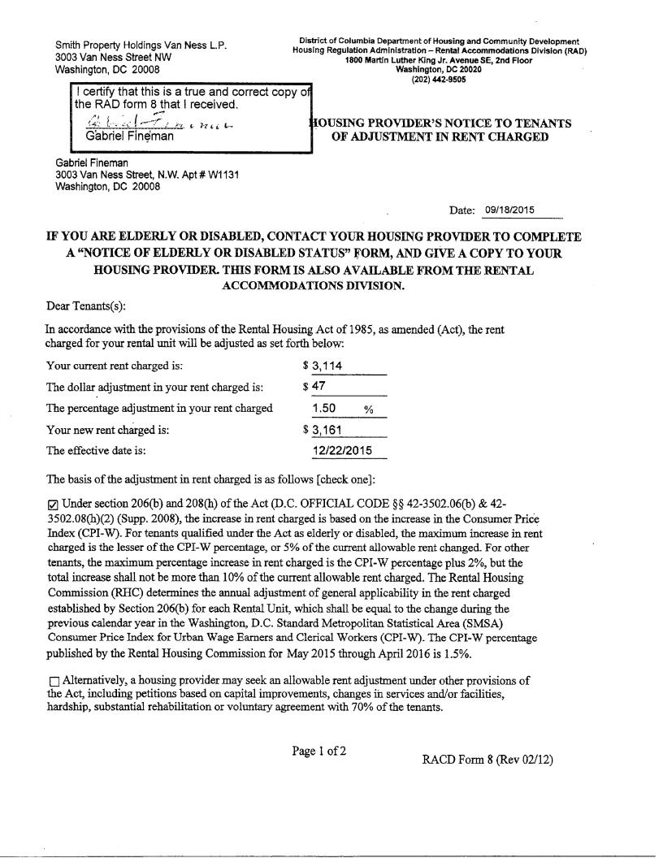
EXHIBIT C
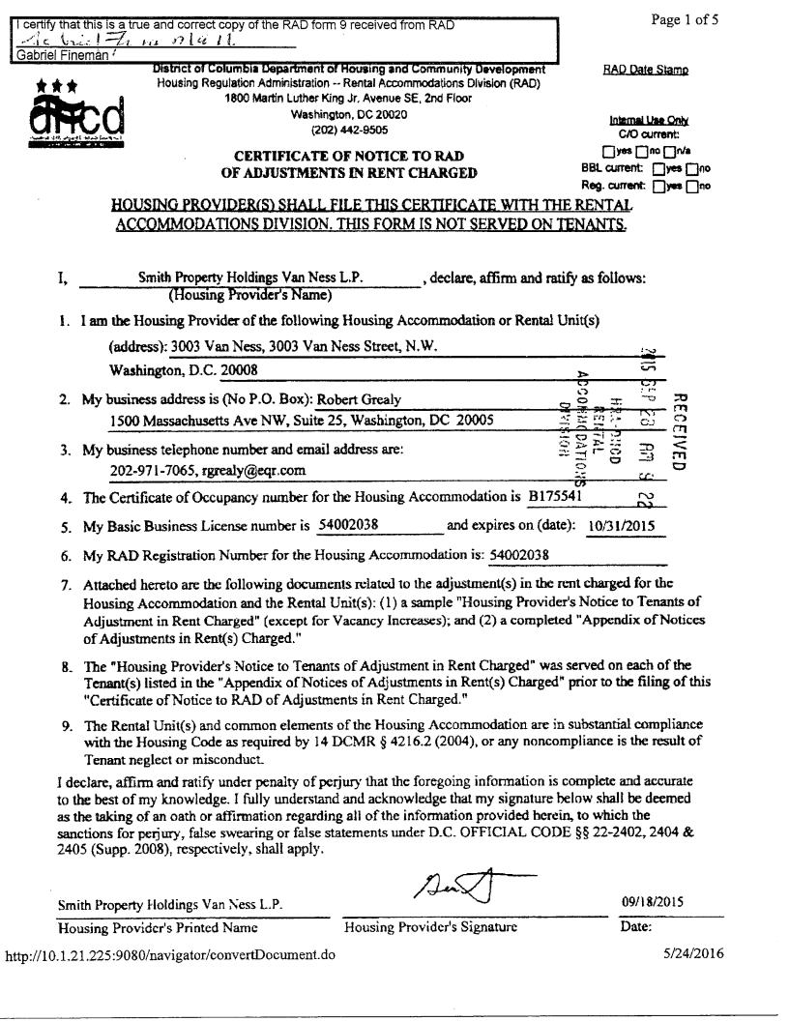
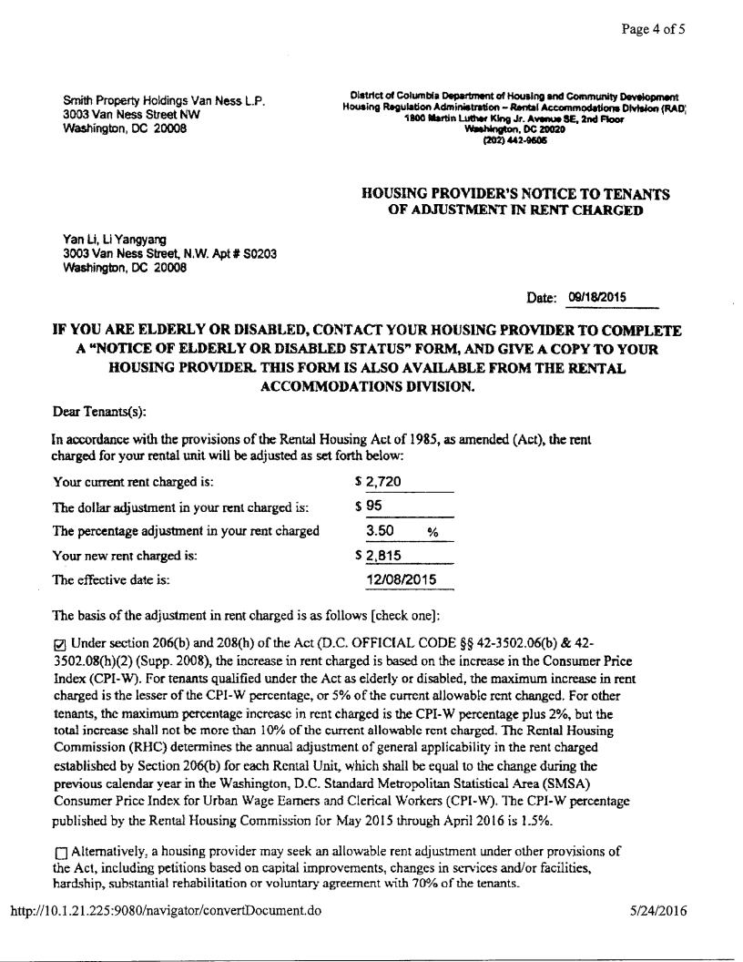
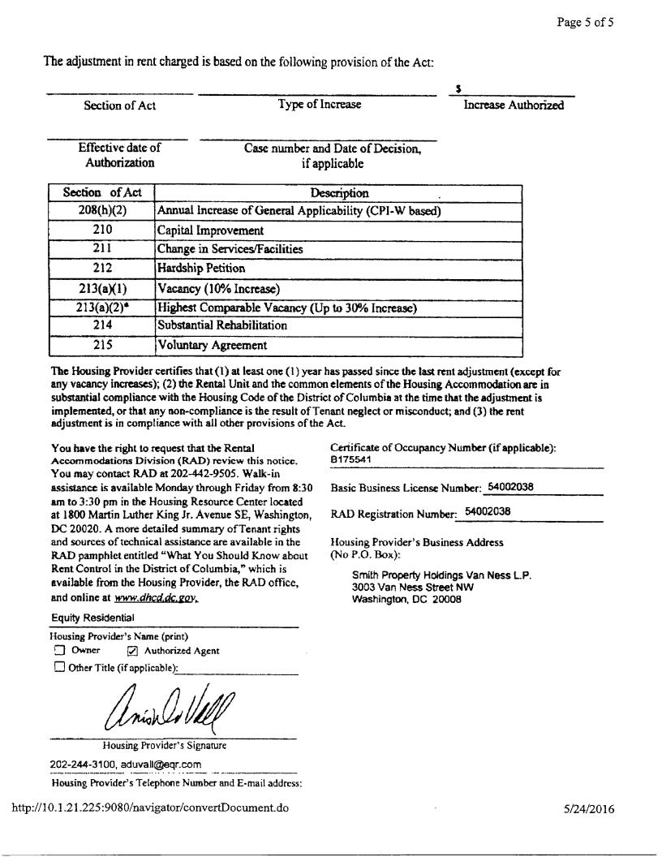
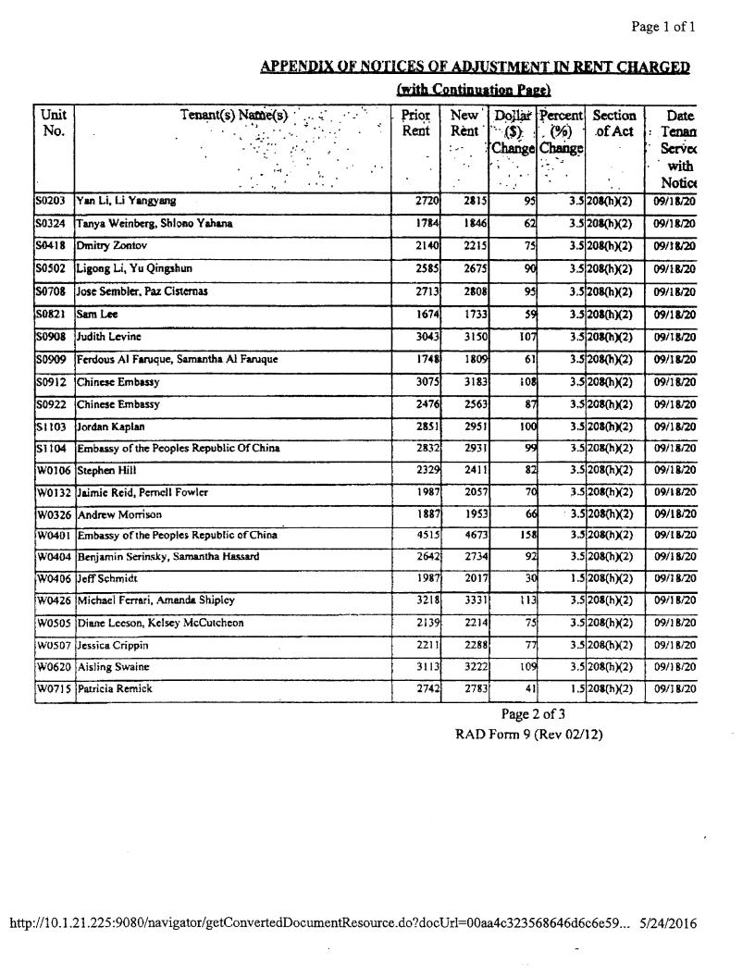
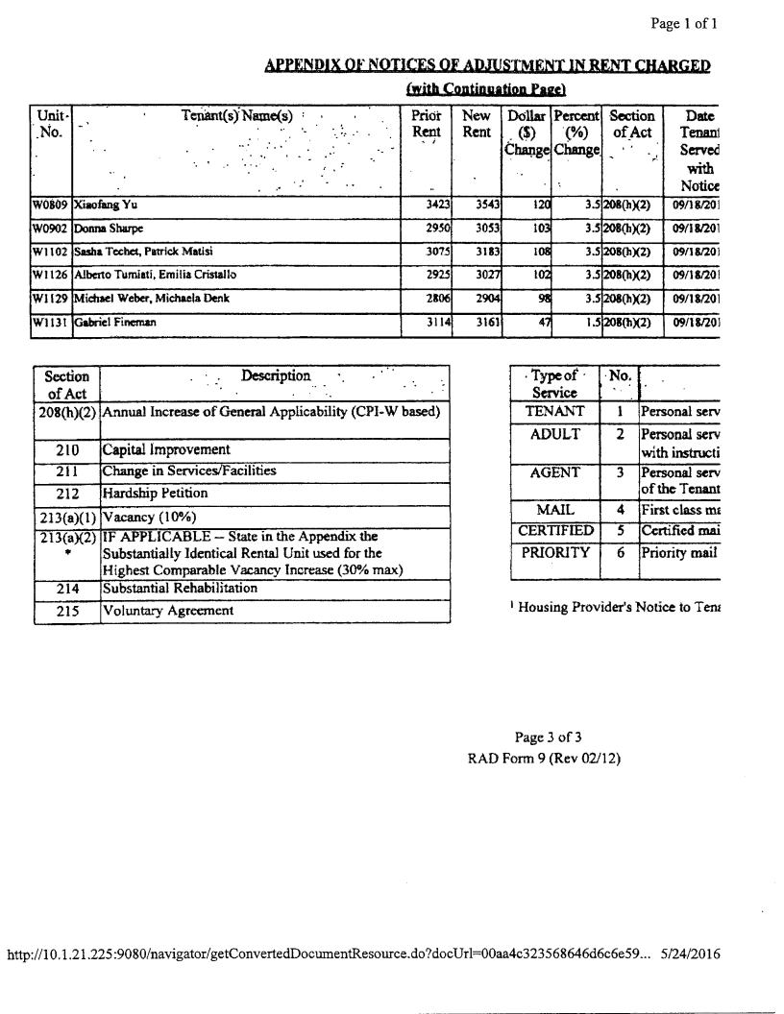
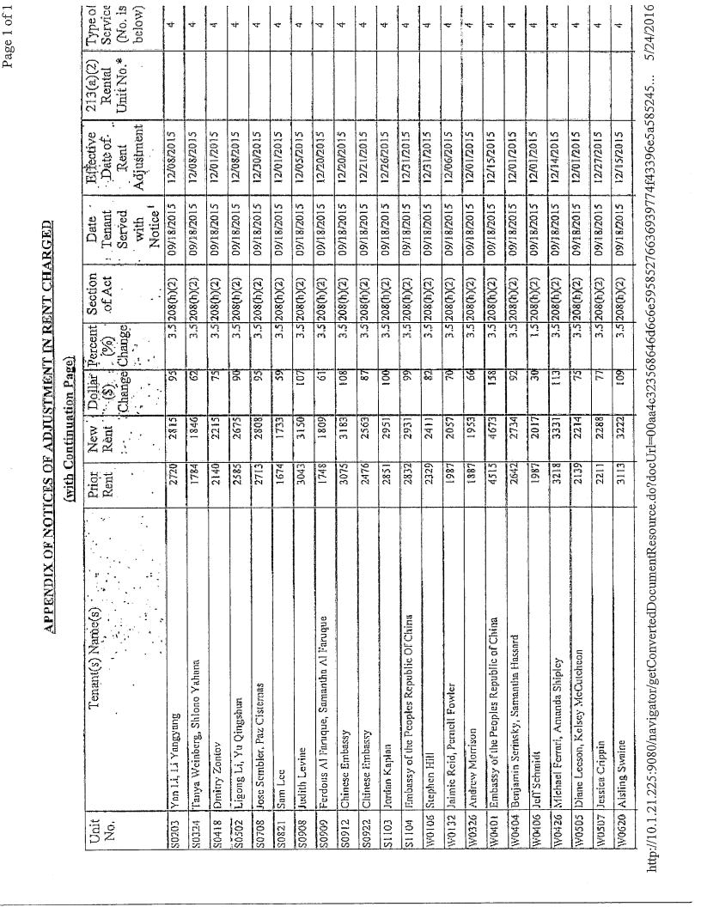
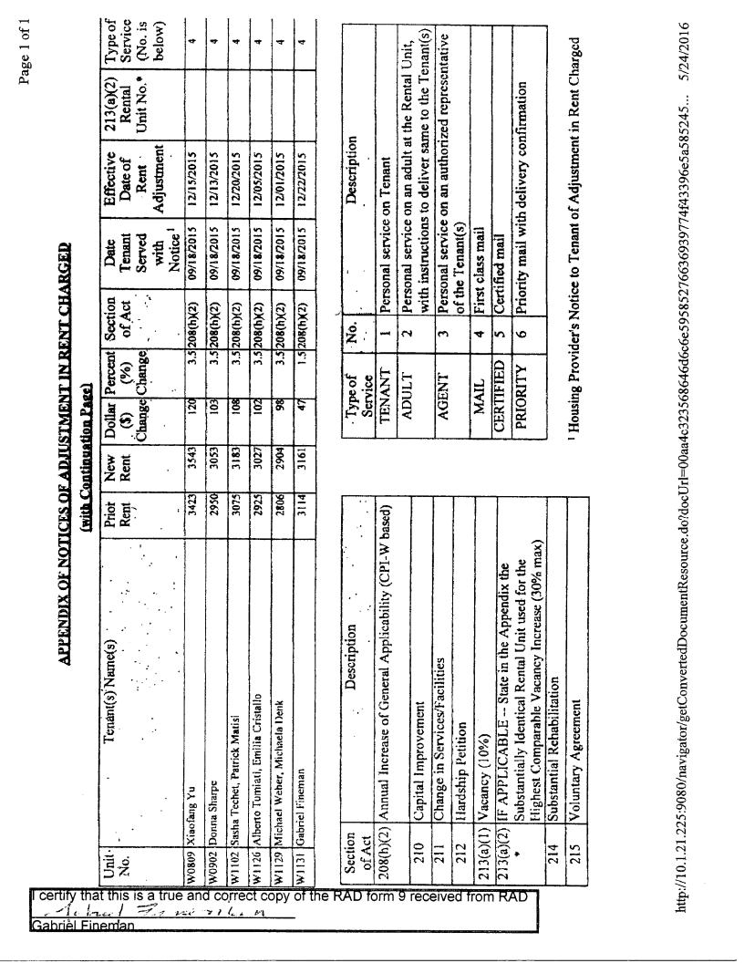
EXHIBIT D

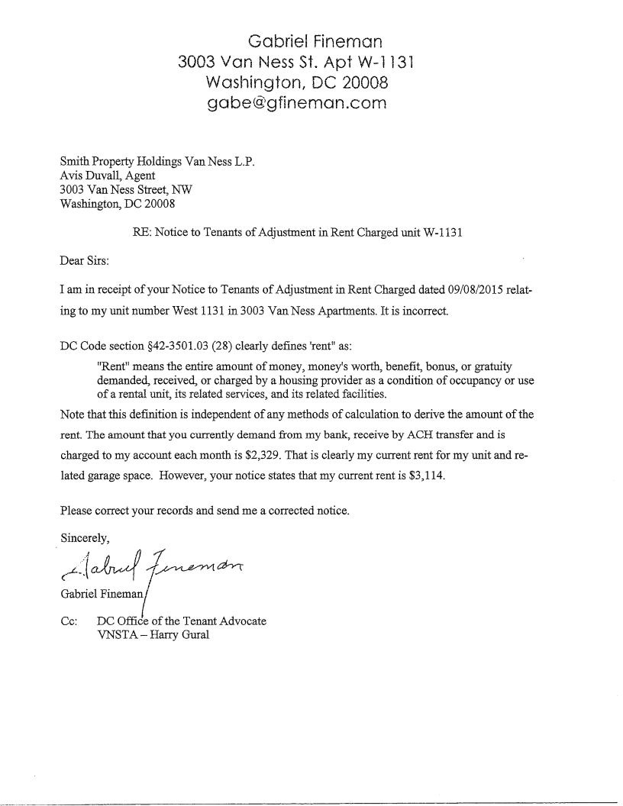
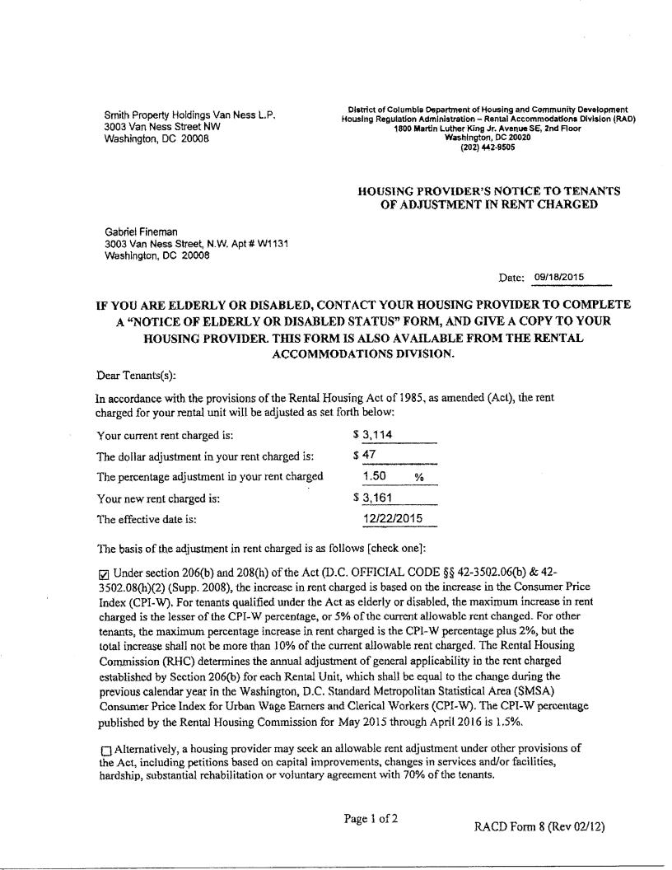
EXHIBIT E

